# ARRAYS:

An array is a collection of similar types of data.

For example,

Suppose we need to record the age of **5** students. Instead of creating **5** separate variables, we can simply create an array:

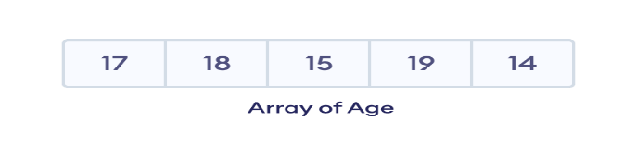

**Creating an Empty array of type Integer**

var value = [Integer]()  
Make sure to use parentheses to signify as empty array

**To Directly Assign values to a variable of type Array:**  
var Values = [1,2,3,4,5]

**To access the values of this array:**

we can achieve this by making use of index:  
for ex: to access “5” from values from above example:

let five = Values[4]

**we can also create array of mixed Data types using the Keyword ANY  
var address:[Any] = [“BLR”, 560037]**

**NOTE: arrays always start from 0**

Hence when comparing with count always consider array.count -1 to check with last element

**1. Using append()  
How to add data to existing Array -> Using APPEND()**var Values = [1,2,3,4,5]suppose if we want to add 6 to array of values we make use of Append  
Values.append(6)

Append()

**Will always add element to end of array**

How Can I append/merge two Arrays -> **array1.Append(contentsOf: array2)  
  
EX:  
var array1 = [1,2,3]**

**Var array2 = [4,5,6]**

**Array1.append(contentsOf: array2)**

**Output: [1,2,3,4,5,6]  
  
2. Using insert()  
  
if we want to insert an element at specific location in an array we make use of insert()  
EX:**

**var array1 = [1,2,3]**

if we want to add “0” at the ‘0’ th element of the array we make use of insert  
  
EX:  
**array1.insert(0, at:0)**

## Modify the Elements of an Array

**Access the element using index and assing value**

**Var values = [0,1,2,3]**

**Values[0] = 00**

**Output = 00,1,2,3**

## Remove an Element from an Array

**Var values = [0,1,2,3]**

**Values.remove(at: 0)**

**Output: 1,2,3**

* removeFirst() - to remove the first element
* removeLast() - to remove the last element
* removeAll() - to remove all elements of an array

**To Iterate over an array using for**

**Var values = [0,1,2,3]**

**For value in values {**

**debugPrint(value)**

## Check if an Array is Empty

The isEmpty property is used to check if an array is empty or not

**OTHER METHODS:**

|  |  |
| --- | --- |
| sort() | sorts array elements |
| shuffle() | changes the order of array elements |
| forEach() | calls a function for each element |
| contains() | searches for the element in an array |
| swapAt() | exchanges the position of array elements |
| reverse() | reverses the order of array elements |

**Extra examples:  
https://www.programiz.com/swift-programming/library/array/allsatisfy**